Title: AI-Powered Text Summarization System
Author: Ahmed Hassan

Problem Statement
With the exponential growth of online information — news articles, blogs, research papers, and reports — it’s nearly impossible for readers to consume everything in detail.
The challenge is to create a system that can automatically summarize long texts into concise, meaningful summaries while preserving the original context.Workflow

Dataset
CNN/DailyMail Dataset — a large-scale benchmark for text summarization containing thousands of news articles with human-written highlights.
Each record includes:
- Article: Full news content
- Highlights: Reference summary
For efficiency, a smaller subset was used during training:
- Train set: 5,000 samples
- Validation set: 500 samples
- Test set: 500 samples

EDA (Exploratory Data Analysis)
- Checked for null values and duplicate articles.
- Analyzed article and summary length distributions.
- Found that summaries are typically 10–15% the length of articles.
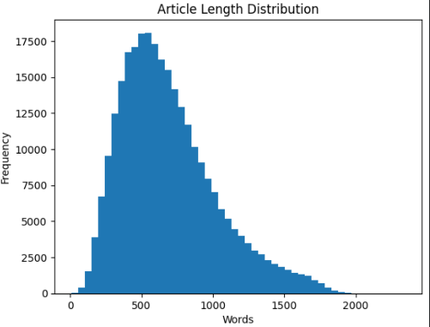

Models Used

T5-Small (Transformer-based)
- Converts all NLP tasks into a text-to-text format.
- Input format: "summarize: [article]".
- Fine-tuned using:
  - Epochs: 2
  - Batch Size: 8
  - Learning Rate: 5e-5
  - Optimizer: AdamW
- Result: Clear, concise summaries with good speed and low memory usage.

PEGASUS (Google Research Model)
- Specifically designed for abstractive summarization.
- Produced more human-like summaries but had a large model size (~2.1 GB).
- Due to deployment constraints, T5-small was selected as the final model.

Best Model:
T5-Small — chosen for its balance between accuracy, speed, and size (≈75 MB after quantization).
Evaluation Metrics (ROUGE Scores):

Deployment
The final T5-Small model was deployed using Flask with two REST API endpoints:
- /summarize_text → Accepts raw text and returns summarized content.
- /summarize_file → Accepts PDF or DOCX file and returns the summary.

Deliverables
- 🧠 Medium Article: “Automatic Text Summarization Using Transformers (T5)”
- 💻 GitHub Repo: https://github.com/ahmedhassan73/Text-Summarizer
- 🎞 Presentation Slides:
Problem → Approach → Models → Results → Deployment → Impact

Results Summary
- Best Model: T5-Small
- Accuracy Metrics:
  - ROUGE-1: 0.24
  - ROUGE-2: 0.09
  - ROUGE-L: 0.19
- Model Size (Quantized): < 80 MB
- Inference Speed: ~1.5 sec per summary on GPU

Key Learnings
- Gained hands-on experience with Transformer architectures (T5, PEGASUS).
- Understood how to preprocess, fine-tune, and evaluate NLP models.
- Learned to deploy ML models efficiently using Flask APIs.
- Explored the trade-off between model accuracy and deployability.

Conclusion
This project demonstrates how AI can automatically summarize long text documents using state-of-the-art Transformer architectures.
While PEGASUS achieved higher accuracy, T5-small proved ideal for deployment due to its smaller size and faster inference speed.
Future work can include multi-language support, domain-specific fine-tuning, and topic-based summarization.

Author
Ahmed Hassan
Data Science & AI Engineer
📍 Buildables Data Science Fellowship — Final Project
🔗 GitHub: github.com/ahmedhassan/text-summarization
🔗 Medium: [https://medium.com/@techwithahmedhassan/text-summarization-using-transformer-models-t5-pegasus-d6ff1124887b]
🔗 LinkedIn: [https://www.linkedin.com/in/ahmedhassan731/
🌐 Live App: [#]

